SAVEETHA SCHOOL OF ENGINEERING
CSA15- CLOUD COMPUTING AND BIG DATA ANALYTICS
LIST OF EXPERIMENTS 3
Name:EDRIN J S
Reg_Number:192524041
Course Code: CSA1504
3. Build a basic cloud-based application for the Property Buying & Rental process in Chennai city, using any Cloud Service Provider, to demonstrate the SaaS model.
Aim
To design and build a cloud-hosted Property Buying & Rental Management System for Chennai city, built on Zoho Creator and roll it out as a Software as a Service (SaaS) application, so that users can search, buy, rent, and manage property details over the internet.

Procedure
- Sign in to Zoho Creator with a valid Zoho account.
- Start a new application called Property Buying & Rental System.
- Build the following forms:
  - Property Information
  - Owner Information
  - Buyer/Tenant Sign-up
  - Booking Details
- Include the necessary fields such as Property ID, Property Type, Location (Chennai), Address, Price, Rent Amount, Owner Name, Buyer/Tenant Name, Contact Number, Email, and Booking Status.
- Set up reports that show available properties, booked properties, and customer details.
- Set up workflows to validate entries and to send confirmation emails for bookings or enquiries.
- Define user roles and permissions for administrators, property owners, and customers.
- Publish the completed application on the Zoho Creator cloud platform.
- Verify the application by adding properties, searching listings, booking a property, and viewing reports through a web browser.

Snapshots:
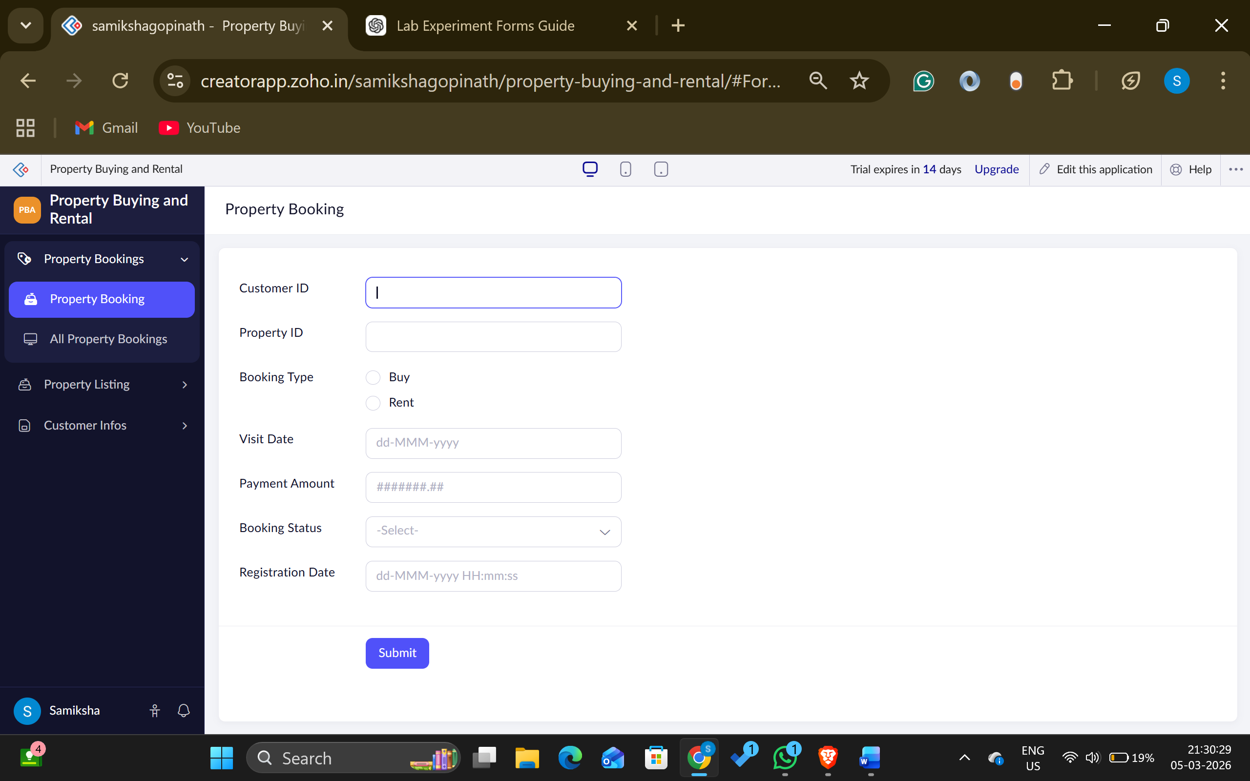
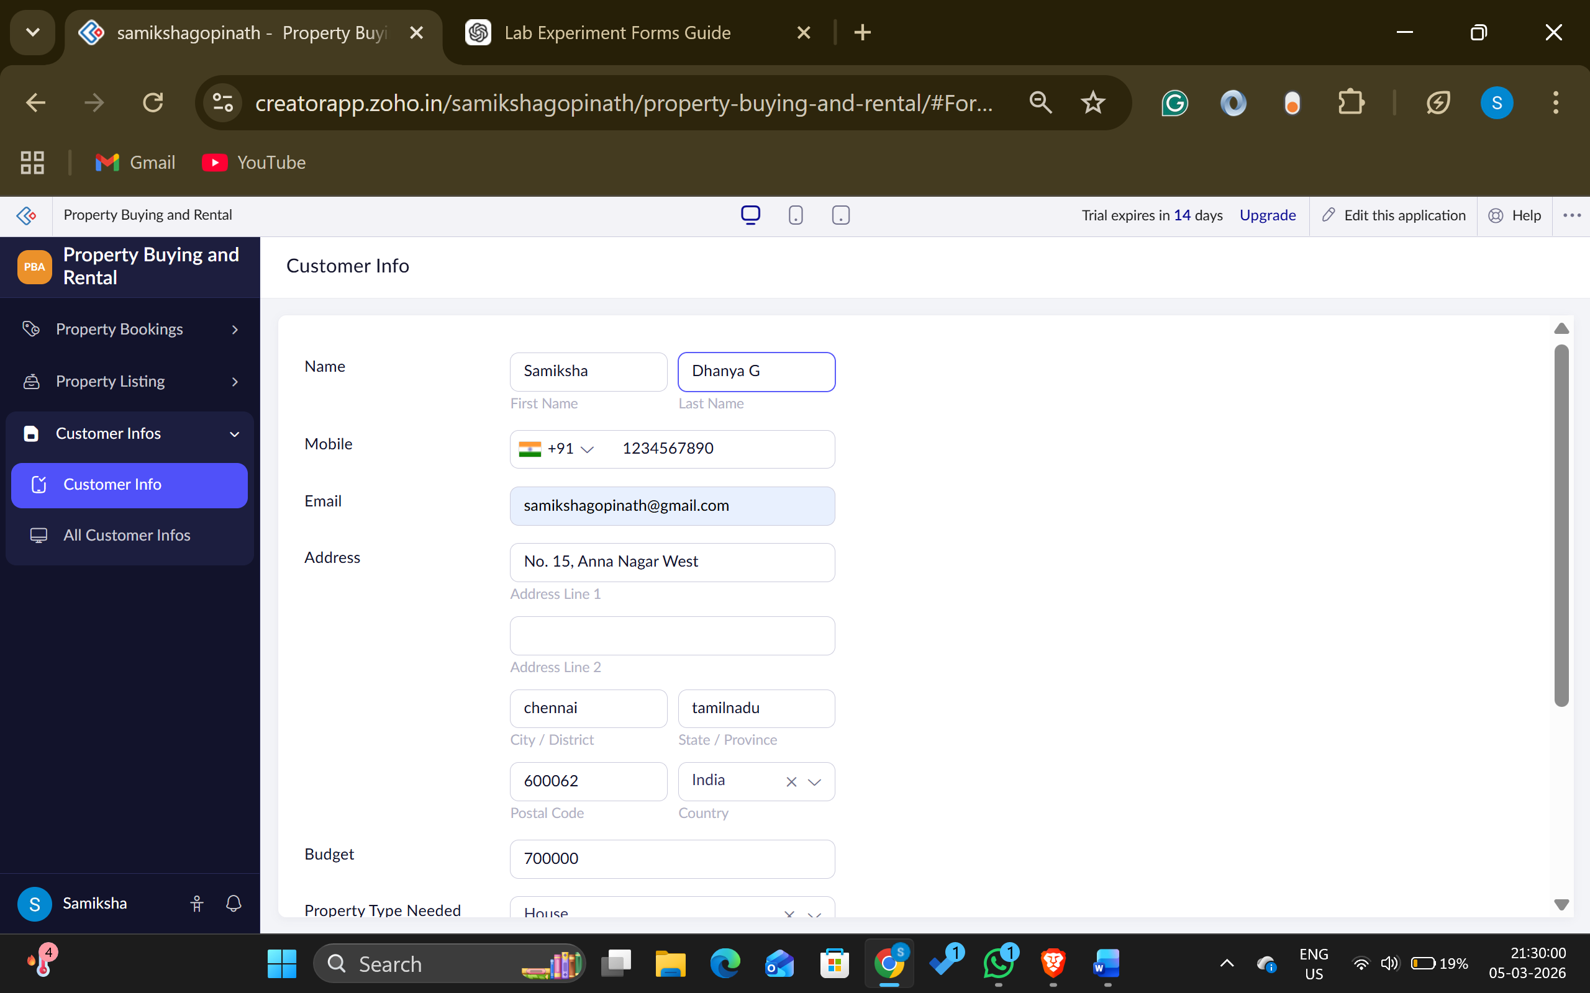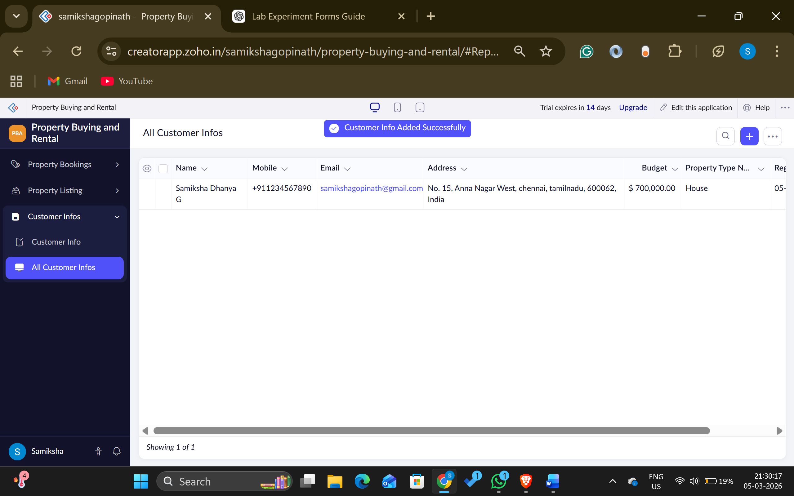
Result
A cloud-hosted Property Buying & Rental Management System for Chennai city was successfully built and deployed using Zoho Creator. Users were able to manage property listings, enquiries, and bookings online, confirming the Software as a Service (SaaS) model by delivering secure, web-based access with no local installation required.

